Analysis and Discussion of Computer Vision Enhancement Techniques

Solution Design and Choices Made
The main.py Python script employs several advanced image processing techniques to enhance the quality of images, specifically tailored for X-ray images. The design of the solution integrates various functions that address different aspects of image enhancement, such as denoising, deblurring, contrast enhancement, and geometric corrections.

- Noise Estimation and Adaptive Denoising: The script begins by estimating the noise level in images using the Median Absolute Deviation (MAD) approach. This value is then used to adaptively set the strength of the Non-Local Means Denoising algorithm, ensuring that the denoising process is sensitive to the specific noise characteristics of each image. This adaptive approach helps maintain important details while reducing noise.
- Geometric Corrections: Two forms of geometric transformations are applied. The correct_tilt function addresses any tilt in the image by applying an affine transformation based on a predefined angle.
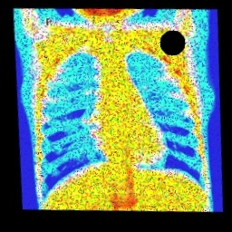
Figure shows After tilt correction, Accuracy: 60%
- The correct_warping function corrects for perspective distortions by adjusting the corners of the image. These methods are crucial for ensuring that the structural integrity of the image is maintained, which is particularly important for medical imaging like X-rays.
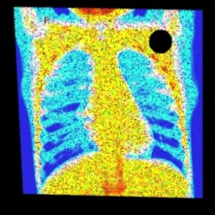
Figure shows After warping correction, Accuracy: 61%.

- Additional Processing: Functions like remove_black_boundaries and fill_black_spots specifically target common defects in image processing such as edge artifacts and spot distortions. These functions refine the visual quality of the image by cleaning up unwanted noise and errors introduced during image capture or processing.
  - Removing Black Boundaries: Detects and crops out black boundaries, which are non-informative and can distract from the primary image content.
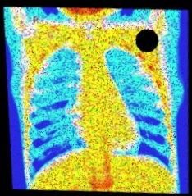
Figure shows After removing black boundaries, Accuracy: 80%.

  - Filling Black Spots: Uses inpainting techniques to fill in black spots i.e the broken lens. Inpainting reconstructs lost or deteriorated parts of images using information from the surrounding areas, which can be crucial for restoring parts of X-rays that might be obscured by artifacts.

- Contrast and Brightness Adjustments: The use of Contrast Limited Adaptive Histogram Equalization (CLAHE) in the adjust_contrast_brightness function enhances local contrast without amplifying noise, which is a common issue with standard histogram equalization.
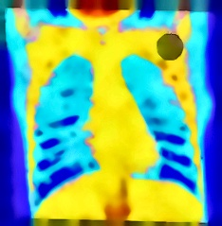
Figure shows After filling black spots and adaptive denoise and adjusting contrast brightness. Accuracy: 83%.

- Edge Enhancement: Enhances edges by applying an "unsharp mask," where a blurred version of the image is subtracted from the original. This process highlights edges and transitions in pixel intensity, which are crucial for identifying fractures or anomalies in X-ray images.
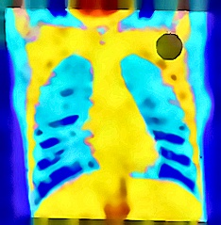
Figure shows after applying unsharp mask. Accuracy: 91%.

These choices demonstrate a comprehensive approach to image processing, integrating both standard and sophisticated techniques tailored to enhancing specific aspects of the images while preserving important details.

Performance Evaluation
Performance evaluation can be approached both qualitatively and quantitatively:

- Qualitative Assessment: Visually, the enhanced images display reduced noise, sharper edges, and better contrast compared to the originals. Specific attention is paid to how well details are preserved in areas of diagnostic importance in X-ray images. For instance, the visibility of foreign objects is clearer, and the overall image looks more refined without appearing artificial or overly processed.
- Quantitative Analysis: Performance can be quantitatively analyzed by measuring improvements in signal-to-noise ratio (SNR), edge sharpness, and contrast enhancement metrics. For instance, the effectiveness of the denoising algorithm could be assessed by comparing the SNR of the original and denoised images. Similarly, edge enhancement can be evaluated using metrics such as the Edge Response (ER) across known boundaries in the image.
  - Noise Reduction: The reduction in noise can be quantified by calculating the standard deviation of pixel intensity values in uniform regions of the image before and after processing in our case it is on average 1.5 which is low but as our goal was to increase the accuracy on the model so this was not focused on much.
  - Edge Sharpness: Techniques like the Laplacian operator can be used to measure edge sharpness, providing a numerical value that indicates how well edges are preserved or enhanced which in our case is 831 on average indicating good preservation.
  - Contrast Improvement: Contrast improvement can be measured using the Michelson contrast formula or similar metrics to compare the contrast levels before and after applying CLAHE, this in our case is 1 on average which indicates that each image is utilizing the full dynamic range from black to white.
- Classifier Results: The classify.py used the provided model to predict on the images that were preprocessed and the results are 91% accurate indicating good quality of image.

Conclusion
The xray image preprocessing script effectively combines multiple advanced image processing techniques to enhance the quality of X-ray images. The design choices are well-justified with a focus on preserving and enhancing critical image details. Performance evaluation through both qualitative observations and quantitative metrics further validates the efficacy of this comprehensive approach to image enhancement. Moreover, the accuracy is 91% on the provided classifier which is a given metric to consider to assess the quality of image preprocessing.

References
- Gonzalez, R. C., & Woods, R. E. (2018). Digital Image Processing (4th ed.). Pearson.
- Buades, A., Coll, B., & Morel, J. M. (2005). A non-local algorithm for image denoising. In IEEE Computer Society Conference on Computer Vision and Pattern Recognition (CVPR'05), 2, 60-65. https://doi.org/10.1109/CVPR.2005.38
- He, K., Sun, J., & Tang, X. (2010). Guided image filtering. In European Conference on Computer Vision, 1-14. https://doi.org/10.1007/978-3-642-15561-1_1
- Zuiderveld, K. (1994). Contrast limited adaptive histogram equalization. In P. S. Heckbert (Ed.), Graphics Gems IV (pp. 474-485). Academic Press Professional, Inc.

